# CHAPTER 1: INTRODUCTION

## Introduction

## The world wide web have spread crosswise over a large number of family unit, so normally, Internet has progressed toward becoming by a wide margin the best stage for land advertising today. Presently days when everything is on the web, how is it conceivable that land deserted web application. There are parcel of real estate organizations who promote their property on the web so thought behind building up this application is that their property can likewise sell, or purchase investment property utilizing this. These application are not broadly famous but rather in future, they have substantial extent of development. This site is an online land the executives through which singular operators or purchaser can keep up their property record keeping and overseeing property enrollment and furthermore get to its data and deal with all the including, refreshing, erasing the as and a portion of its tasks. The Admin client can educate their specialists for regarding to property and update the data in regards to property and wiping out of property or changing buyer decision. The framework is exceptionally helpful for the organizations or developers that can post and alter their properties and their own information and administrator can screen records of all of them. The framework is likewise valuable which additionally monitors Account subtleties of purchasers and Investors and furthermore RES Industry. Through this site a client can get to its data and deal with all the adding, updating and deleting the advantages and a portion of its errands. The Admin client can change the update the data in regards to property selling and purchasing. Organizations or individual operators can likewise promote their property

## 1.2 Project Overview

In an era of social media and connectivity, web users are becoming increasingly enthusiastic about working together through online media. With a growing impact on everyday life, such as in education, health, commerce and tourism, leading to an exponential growth in the size of the social web. However, to find a house to own is a big task in this real world due to fake agents and wrong persons. We will hence focus on to connect the buyers and sellers under one roof to facilitate them with the approved houses and with ease to find the homes with the provided facilities according to the need of the buyers. To do this challenging task, we first need to build a cross functional platform and find the users who are in the need of the houses and then we have to find the sellers or real estate managers who will help the buyers to buy their houses.

## Objectives

## System Portal should have a same login for buyers and sellers.

## All the Buyers and Sellers should be able to update the details.

## Admin should have authority to approve the houses for the sellers.

* Admin can Add, Update and Delete the Sellers also.

## Seller should maintain the property. Seller can Add, Update and Delete their houses according to the need.

* System should have filters to filter the houses according to price, type and facilities that are available in the list of houses.

## Buyer should book the property for and contact to the seller for the documents verification and all other things.

## The system plays a major role for the companies or builders to find the property according to their needs.

## 1.4 Methodology

**Agile Methodology**

Agile is a software development approach where a self-sufficient and cross-functional team works on making continuous deliveries through iterations and evolves throughout the process by gathering feedback from the end users.Agile is one of the world's most broadly utilized and perceived programming advancement system. A large portion of the organizations have adopted in some structure or the other yet there is as yet far to go in the development of their reception programs. The sole point of this arrangement of instructional exercises is to installed innovation and non-innovation experts into the Agile World.

The Agile procedure imagines change and thinks about fundamentally more versatility than traditional techniques. Clients can take off little target enhancements without tremendous changes to as far as possible or schedule. The technique incorporates isolating each errand into sorted out requirements, and passing on each only inside an iterative cycle. An accentuation is the every day time table of developing little sections of an endeavor at some random minute. Each accentuation is assessed by the headway gathering and client. The encounters got from the examination are used to choose the resulting stage being created. Clients come to standard social affairs to review the work completed in the past accentuation, and to configuration work for the best in class cycle. Ordered targets are set in each accentuation meeting, for instance, anticipated changes, time evaluations, needs and spending plans.

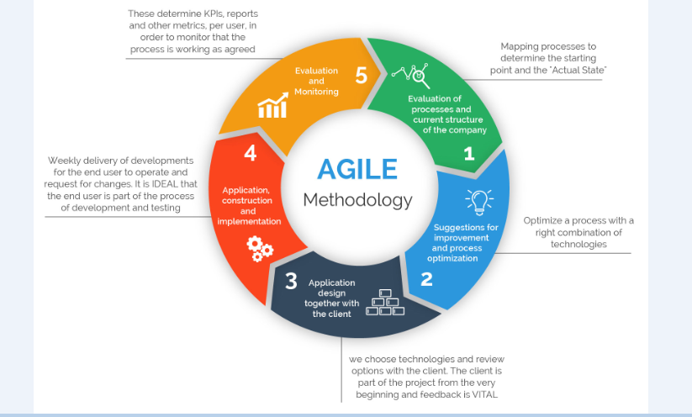

Figure 1. The Agile Methodology

There are many Agile procedures used across the world. The one used in this project is Scrum.

**Scrum**

Scrum is an agile advancement system which centers unequivocally around the most capable strategy to manage different tasks inside a group. It involves both Iterative and Incremental strategy for item improvement. The scrum in IT takes confidence in connected independently directed improvement bunches with three express and indisputably described occupations. These employments join – Product Owner (PO), Scrum Master (SM) and the headway bunch involving the software engineers and testers. They coordinate in iterative time boxed ranges called sprints. The initial step is the making of the product backlog by the PO. It's an arrangement for the day of stuff to be done by the scrum group. By then the scrum group picks the top required things and endeavors to finish them inside the time box called a sprint.

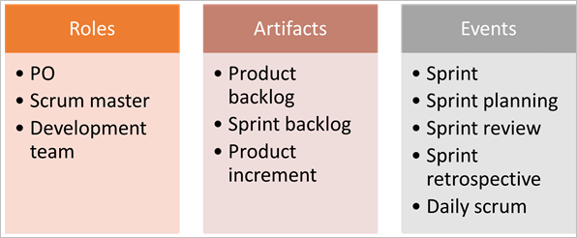

Figure 2. The Scrum Framework

**Scrum Terminologies:**

1. **Scrum Team**

It is a group incorporating 6 with + or – two people. These people acquire a mix of capacities and incorporate designers, database individuals, developers, testers, and so forth just as the scrum ace and PO. All of these people coordinate in close joint exertion for a recursive and obvious between time, to make and execute the said features. SCRUM bunch sitting arrangement expect a noteworthy activity in their collaboration, they never sit in work area territories or hotels, yet a major table. The group manages its own one of a kind work and deals with the work to complete the run.

1. **Product Owner**

He/she is the key accomplice or the lead customer of the application to be made. The PO is the person who addresses the customer side. He/she has the last say and is should be there for the group.

He/she should be reachable when anyone has any inquiries that need illustration. It is huge for the PO to understand and not to designate any new essential in the midst of the run or when the dash has started.

1. **Scrum Master**

He is the facilitator of the group. He/she guarantees that the scrum group is dynamic and productive. In case of any obstacles, scrum master settles them for the group meetings. Scrum Master is the middle person between the PO and the group.

He/she keeps the PO informed about the improvement of the Sprint. In case there are any problems or stresses for the group, looks at with the PO and gets them settled. Like the group's Daily meetings, a meeting of the SCRUM Master with the PO happens every day.

1. **Sprint**

It is a predefined between time or time distribution in which the work must be done and made arranged for review or arranged for product deployment. This time box customarily lies between around fourteen days to multi month.

In our regular day to day existence when we express that we seek after one month Sprint cycle, it basically suggests that we labor for one month on the endeavors and make it arranged for survey before that month's finished.

1. **Product Backlog**

It is where all the user stories are kept. This is kept up by the Product Owner. It tends to be imagined as a rundown of things wanted by the PO who sorts out it as per the business needs.

At the time of the group meeting, a user story is looked over the product backlog, by then the group does the conceptualizing, gets it and refines it and all things considered picks which user stories to take, with the assistance of the thing client.

1. **User Story**

These are the requirements of the user that have to be fulfilled. In the scrum, we don't have those colossal necessities archives, rather the prerequisites are characterized in a solitary passage, regularly having the arrangement as:

As a <User/Client/Admin>

I need to <Some reachable objective/target>

To accomplish <some result or explanation behind doing the thing>

For instance, if a client enters the wrong password multiple times, the administrator ought to have a password lock to prevent from the unauthorized access.

There are a couple of properties of user stories which should be followed. They should be short, viable, could be assessed, completed, debatable to be proven wrong and testable. A user story is never balanced or changed in the midst of the Sprint.

It is the duty of the SCRUM Master to guarantee that the PO has drafted the User Stories precisely with an authentic course of action of the Acceptance Criteria. If any change which will influence the arrival of sprint are to be made, by then such stories are pulled out of the run or they are finished by the available hours.

Every user story has an affirmation standard which should be particularly portrayed and appreciated by the group.

1. **Sprint Backlog**

In perspective on the need, user stories are taken from the Product Backlog one by one. The Scrum leader conceptualizes on it and chooses the attainability and settles on the accounts to take up at a particular sprint. The total rundown of the considerable number of stories which the whole group deals with in a sprint is called Sprint backlog.

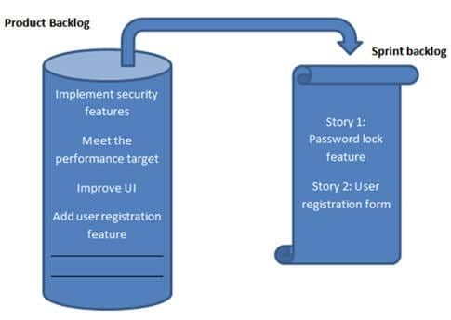

Figure 3. Product and Sprint Backlog

1. **Burn Down Chart**

It is a graph which evaluates the estimated effort v/s actual effort of the decided tasks. For a decided sprint, it tracks the daily divided work to check whether the project is going as decided and towards completion or not.

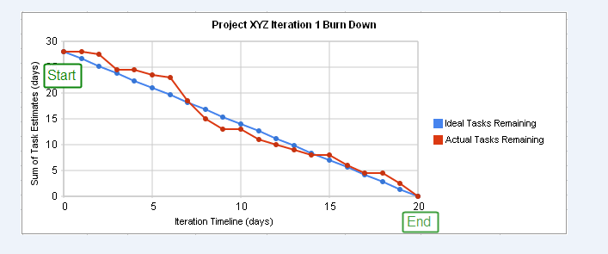

Figure 4. Burn Down Chart

**Flow of process:**

• Sprint is each step of a Scrum.

• List where all tasks are decided and composed to get a final result is called Product Backlog.

• Top things of Product Backlog are given to Sprint Backlog.

• Team completes and delivers product functionalities toward the end of the Sprint.

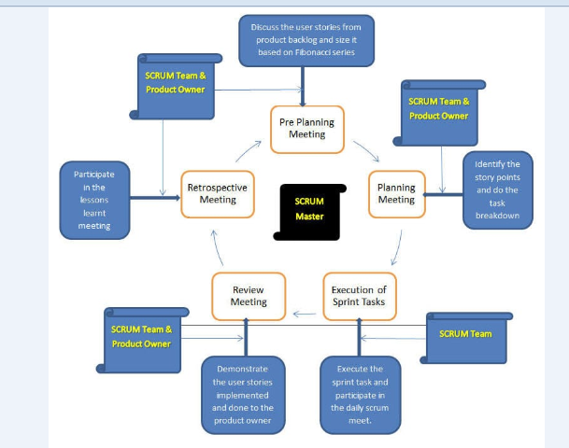

Figure 5. Scrum Process

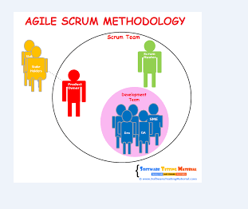

Figure 6. Agile Scrum Methodology

## 1.5 Organization of Thesis

In Chapter 2, we have discussed the literature survey. We have studied about the various technologies that is going to be used in the same project and we have also done some practice of these technologies to get familiar with.

In Chapter 3, we have developed the system design and explained various diagrams that have been used to explain our system.

In Chapter 4, we have discussed about project development process that is going to be used in the project like database design and the other things that are needed in order to develop the project as well.

In Chapter 5, we have done results and performance analysis of the report.

In Chapter 6 we have thereby concluded our report and discussed about the future scope of the projects.

## 1.6 Genesis of Problem

In this modern digital age there are many fake real estate mangers that are present at every corner of the city and are taking money from the poor people and then misguiding them in providing the houses. The information will be put away appropriately in information stores, which will help in recovery of data just as its stockpiling. The accuracy in the proposed framework cannot be chosen. Since here client purchase and another client construct the home. There is no certification. The unwavering quality of the proposed framework will be high because of the above expressed reasons. The purpose behind the expanded unwavering quality of the framework is that presently there would be legitimate capacity of information.

# CHAPTER 2: LITERATURE SURVEY

1. **C#:**

C# is an extensively helpful, broadly useful, straightforward object oriented programming language enunciated as "C sharp". It was made by Microsoft driven by Anders Hejlsberg and his group inside the .Net team meeting and was certified by the International Standards Organization (ISO) and the European Computer Manufacturers Association (ECMA). C# is among the Common Language Infrastructure. C# is an extraordinary arrangement like Java semantically and is straight forward for customers who think about C, C++ or Java. C# has in like manner been found useful in various settings, with key characteristics being customizing establishment and resource obliged applications, including work region applications, servers (for instance online business, Web interest or SQL servers), and execution fundamental applications.

1. **HTML**

HTML represents Hyper Text Markup Language, which is the most generally utilized language on Web to create site pages. HTML was made by Berners-Lee in late 1991 however "HTML 2.0" was the principal standard HTML detail which was distributed in 1995. HTML 4.01 was a noteworthy adaptation of HTML and it was distributed in late 1999. Despite the fact that HTML 4.01 adaptation is broadly utilized yet right now we are having HTML-5 variant which is an augmentation to HTML 4.01, and this rendition was distributed in 2012.

* Hypertext alludes to the manner by which Web pages (HTML reports) are connected together. Along these lines, the connection accessible on a site page is called Hypertext.
* As its name proposes, HTML is a Markup Language which implies you use HTML to just "increase" a content report with labels that advise a Web program how to structure it to show.

1. **CSS**

Cascading Style Sheets, affectionately alluded to as CSS, is a straightforward structure language planned to streamline the way toward making website pages satisfactory.

CSS handles the look and feel some portion of a site page. Utilizing CSS, you can control the shade of the content, the style of text styles, the separating between passages, how sections are measured and spread out, what foundation pictures or hues are utilized, format designs,variations in showcase for various gadgets and screen sizes just as an assortment of different impacts.

CSS is anything but difficult to learn and see yet it gives amazing authority over the introduction of a HTML record. Most ordinarily, CSS is joined with the markup dialects HTML or XHTML.

1. **JavaScript**

JavaScript is a dynamic programming language. It is lightweight and most normally utilized as a piece of web pages, whose executions permit customer side content to communicate with the client and make dynamic pages. It is a translated programming language with item situated capacities.

JavaScript was first known as LiveScript, yet Netscape changed its name to JavaScript, perhaps on account of the fervor being created by Java. JavaScript showed up in Netscape 2.0 in 1995 with the name LiveScript. The broadly useful center of the language has been implanted in Netscape, Internet Explorer, and other internet browsers.

The ECMAScript Edition 5 standard will be the principal update to be discharged in more than four years. JavaScript 2.0 complies with Edition 5 of the ECMAScript standard, and the distinction between the two is very minor.

Today, Netscape's JavaScript and Microsoft's JScript comply with the ECMAScript standard, albeit both the dialects still help the highlights that are not a piece of the standard.

1. **Angular 6**

Angular 6 is a JS(JavaScript) framework for structure web applications and applications in JavaScript, HTML and TypeScript, which is a superset of JavaScript. Angular gives worked in highlights to view(UI) and materials which truly has highlights, for example, auto-complete, route, toolbar, menus, and so forth. The code is written in TypeScript, which aggregates to JavaScript and features the in the same browser.

It is used to make Form-based applications, Web-based applications, and Web organizations. It is used to develop applications for Windows, web, mobile and other OS. It gives a huge amount of functionalities and moreover supports industry models.

1. **Bootstrap**

Bootstrap is an open source toolkit for developing with HTML, CSS, and JS. Quickly prototype your ideas or build your entire app with our Sass variables and mixins, responsive grid system, extensive prebuilt components, and powerful plugins built on jQuery.

Twitter Bootstrap is the most popular front end framework in the recent time. It is sleek, intuitive, and powerful mobile first front-end framework for faster and easier web development. It uses HTML, CSS and Javascript. This tutorial will teach you the basics of Bootstrap Framework using which you can create web projects with ease. The tutorial is divided into sections such as Bootstrap Basic Structure, Bootstrap CSS, Bootstrap Layout Components and Bootstrap Plugins.

1. **Visual Studio**

Visual Studio is an Integrated Development Environment(IDE) made by Microsoft to make GUI (Graphical User Interface), Web applications, support, adaptable applications, cloud, versatile and web applications, etc. With the help of this IDE, you can make oversaw code similarly as nearby code. It uses the various phases of Microsoft programming headway programming like Windows store, Windows API and Microsoft Silverlight, etc. It's definitely not a language unequivocal IDE as you can use this to form code in C#, Angular, C++, JavaScript, Python and significantly more dialects. It offers assistance for 36 various languages. It is available for Windows similarly with respect to macOS.

The primary type of VS (Visual Studio) was made in 1997, called as Visual Studio 97 having adjustment number 5.0. The latest adjustment of Visual Studio is 15.0 which was released on March 7, 2017. It is moreover named as Visual Studio 2017. The maintained .Net Framework Versions in latest Visual Studio is 3.5 to 4.7. Java was maintained in old versions of Visual Studio anyway in latest structure doesn't give any help to Java language.

1. **Model View Controller**

The Model-View-Controller (MVC) is a plan that detaches an application into three rule rational portions: the model, the view, and the controller. All of these sections are attempted to manage express headway parts of an application. MVC is a champion among the most a significant part of the time used industry-standard web improvement structure to make versatile and extensible endeavors.

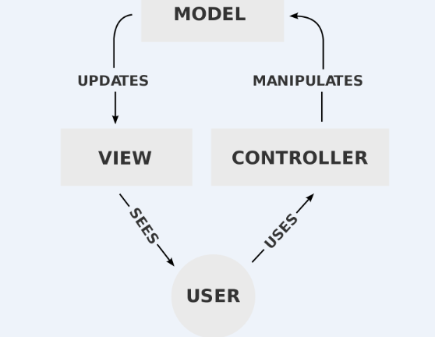

Figure 7. Components of MVC

Components of MVC are listed below:

* Model - The Model portion looks at to each datum related data that the customer works with. This can address either the data that is being exchanged between the View and Controller sections or some different business method of reasoning related data. For example, a Customer article will recoup the customer information from the database, control it and update it data back to the database or use it to render data.
* View - The View fragment is used for all the UI justification of the application. For example, the Customer view will fuse all the UI portions, for instance, dropdowns, content boxes etc that the last customer speaks with.
* Controller - Controllers go about as an interface among Model and View parts to process all the business basis and moving toward requesting, control data using the Model fragment and partner with the Views to render the last yield. For example, the Customer controller will manage all of the associations and commitments from the Customer View and update the database using the Customer Model. A comparable controller will be used to see the Customer data.

1. **SSMS**

It is a workstation customer component that will be presented in the occasion in the event that we select workstation portion in foundation steps. This empowers you to connect with and manage your SQL Server from a graphical interface instead of using the course line.

In order to connect with a remote event of a SQL Server, you will require this or practically identical programming. It is used by Administrators, Developers, Testers etc.

1. **Entity Framework**

Previously .NET 3.5, originators consistently used to form ADO.NET code or Enterprise Data Access Block to save or recuperate application data from the shrouded database. They used to open a relationship with the database, make a DataSet to get or exhibit the data to the database, convert data from the DataSet to .NET things or the other route around to apply business rules. This was an ambling and slip-up slanted methodology. Microsoft has given a framework called "Substance Framework" to modernize every one of these databases related activities for your application.

Substance Framework is an open-source ORM framework for .NET applications maintained by Microsoft. It engages architects to work with data using objects of room express classes without focusing on the fundamental database tables and areas where this data is secured. With the Entity Framework, designers can work at a progressively raised measure of reflection when they oversee data, and can make and keep up data organized applications with less code differentiated and standard applications.

Official Definition: "Component Framework is an article social mapper (O/RM) that engages .NET specialists to work with a database using .NET things. It discards the necessity for a substantial bit of the data get the opportunity to code that engineers by and large need to make."

The going with figure speaks to where the Entity Framework fits into your application

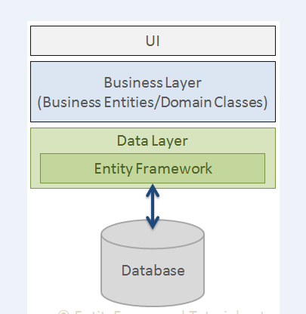

Figure 8. Entity Framework

As indicated by the figure, Entity Framework fits between the business components (region classes) and the database. It saves data set away in the properties of business components and moreover recoups data from the database and changes over it to business substances protests thus.

The approach that is used is database first approach.

1. **Database first approach**

Database First Approach makes the Entity Framework from a present database. It makes model codes from database. The database in the endeavor and those classes become the association between the database and controller.

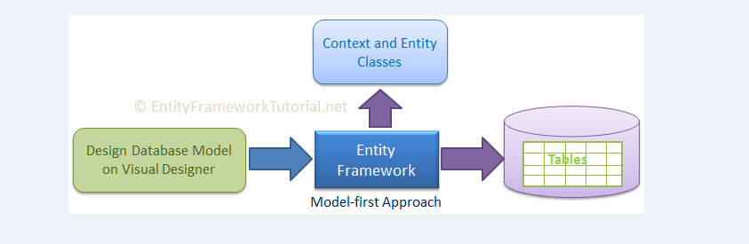

Figure 9. Database First Approach

1. **Application Programming Interface(API)**

An application programming interface (API) is a lot of conventions, schedules, capacities and additionally directions that developers use to create programming or encourage collaboration between unmistakable frameworks. APIs are accessible for both work area and versatile use, and are normally valuable for programming GUI (realistic UI) components, just as permitting a product program to ask for and suit administrations from another program.

An API can be viewed as made out of two key components: a specialized particular that sets up how data can be traded between projects (which itself is comprised of solicitation for preparing and information conveyance conventions) and a product interface that by one way or another distributes that detail.

The essential idea driving the API has existed in some structure for the whole history of advanced innovation, as the cooperation between novel projects and computerized frameworks has been an essential target for a lot of that innovation's presence. In any case, with the ascent of the internet, and the consequent turn-of-the-thousand years website blast, the motivating force for this innovation achieved a phenomenal dimension.

The API turned out to be particularly conspicuous in the expanding business division of the internet in mid 2000, when Salesforce.com consolidated the innovation into its stage so as to enable clients to share and transmit information over their assorted business applications. Not long after from that point onward, eBay started taking off comparative innovation, and with the ascent of online life a couple of years after the fact, organizations like Flickr, Facebook, Twitter and Instagram started doing likewise.

1. **Encryption/ Decryption:**

In processing, encryption is the strategy by which plaintext or some other kind of information is changed over from a discernible structure to an encoded adaptation that must be decoded by another element in the event that they approach an unscrambling key. Encryption is a standout amongst the most significant techniques for giving information security, particularly for start to finish insurance of information transmitted crosswise over systems.

Encryption is broadly utilized on the web to ensure client data being sent between a program and a server, including passwords, installment data and other individual data that ought to be viewed as private. Associations and people likewise generally use encryption to ensure delicate information put away on PCs, servers and cell phones like telephones or tablets.

Decryption is the way toward changing information that has been rendered mixed up through encryption back to its decoded structure. In decryption, the framework concentrates and changes over the confused information and changes it to writings and pictures that are effectively reasonable by the peruser as well as by the framework. Decryption might be cultivated physically or consequently. It might likewise be performed with a lot of keys or passwords.

One of the first purposes behind executing an encryption-decryption framework is security. As data goes over the World Wide Web, it ends up subject to examination and access from unapproved people or associations. Thus, information is encoded to lessen information misfortune and burglary. A portion of the basic things that are scrambled incorporate email messages, content documents, pictures, client information and indexes. The individual accountable for decryption gets a brief or window where a secret phrase might be entered to get to scrambled data.

# CHAPTER 3: SYSTEM DEVELOPMENT

The whole website is developed using the Agile Methodology. This project is done by splitting it into two parts known as sprints of 14 days each. The web based application is developed using Angular 6 for the front-end and SQL Server at the back-end. The language used is C#. The tool used for programming is Visual Studio 2017 and for SQL, it’s SQL Server Management Studio (SSMS).

**3.1 Software Requirements**

Client End : Internet Explorer, Operating System(Windows)

Developer End :Visual Studio 2017, Operating System(Windows)

Servers : Microsoft Windows 2007, SQL Server 2000(SSMS)

Services : ASP.NET Web Services

**3.2 Hardware Requirements**

Processor/RAM/HDD : 2

Web server : Any suitable servers can be used

Database Server : Any suitable servers can be used

Primary Memory : 1 GB or Higher RAM

**3.3 Functional Requirements**

**REGISTER:**

* Only registered buyer and seller can buy a house.
* Every buyer and seller has to provide proper details while registering.
* Without registering, no one can avail the facilities.
* Admin can be there for approval of the houses.

**USER (Buyer or Seller):**

* Seller can add their own house with their provided facilities.
* Only logged in user should able to see the contact information of the sellers.
* Seller can add multiple houses.
* Buyer can purchase multiple houses.
* Buyer should be able to contact seller.
* Seller should be able to view his houses.
* Buyers and sellers can see all houses that are present.

**ADMIN:**

* Admin should manage adding of new vendor, updating, removing etc.
* For a package with successful booking, an auto generated greeting can be sent on the day of their event.

## 

## 3.4 Requirements Out Of Scope

* Payment gateway for the buyers.
* Chat facility of the buyer and seller within the application.

## 3.5 User Interface(UI)

* Should be user friendly.
* Should adapt to different screen sizes of screens.
  1. **Sprint Work**

**Sprint 1 Work:**

A User Story is the prerequisite or requirements of the user that have to be fulfilled. Following are the User Stories or the tasks that have to be accomplished in the project:

* US 01 – As a Buyer, I should be able to Register.
* US 02 – As a Buyer, I should be able to Login.
* US 03 – As a Buyer, I should be able to view all the houses that are present.
* US 04 – As a Buyer, I should be able to view the details of the specific house.
* US 05 – As a Buyer, I should be able to get the details of the seller.
* US 06 – As a Buyer, I should be able to update the credentials.
* US 07 – As a Buyer, I should be able to get the facilities of the house.
* US 08 – As a Buyer, I should be able to View Houses based on Location.
* US 09 – As a Buyer, I should be able to View Houses based on Type.
* US 10 – As a Buyer, I should be able to View Houses based on Price.
* US 11 – As a Buyer, I should be able to Logout.
* US 12 – As a Seller, I should be able to Register.
* US 13 – As a Seller, I should be able to Login.
* US 14 – As a Seller, I should be able to View all Houses.
* US 15 – As a Seller, I should be able View the houses that are added by seller.

**Sprint 2 Work:**

* US 16 – As a Seller, I should be able to add new house.
* US 17 – As a Seller, I should be able to Update house details.
* US 18 – As a Seller, I should be able to Delete the House.
* US 19 – As a Seller, I should be able to update my Credentials.
* US 20 – As a Seller, I should be able to Logout.
* US 21- As a Admin, I should be able to Login.
* US 22- As an Admin, I should be able to view all the houses.
* US 23- As an Admin, I should be able to verify the houses.
* US 24- As an Admin, I should be able to Delete the houses.
* US 25- As an Admin, I should be able to Logout.
  1. **Use Case Diagrams:**

A use case outline is a realistic portrayal of the collaborations among the components of a framework.

A use case is a procedure used in framework examination to recognize, clear up, and compose framework necessities. In this specific situation, the expression "framework" alludes to something being created or worked, for example, a mail-request item deals and administration webpage. Use case outlines are utilized in UML (Unified Modeling Language), a standard documentation for the displaying of genuine articles and frameworks.

Framework destinations can incorporate arranging generally speaking necessities, approving an equipment configuration, testing and troubleshooting a product item being worked on, making an online assistance reference, or playing out a buyer administration situated assignment. For instance, use cases in an item deals condition would incorporate thing requesting, index refreshing, installment preparing, and client relations. A use case chart contains four segments.

The limit, which characterizes the arrangement of enthusiasm for connection to it's general surroundings. The on-screen characters, as a rule people required with the framework characterized by their jobs. The use cases, which are the particular jobs played by the entertainers inside and around the framework. The connections between and among the entertainers and the use cases.

Here are some use case diagrams of website which will show the proper functionality of every user:

* **Buyer:**

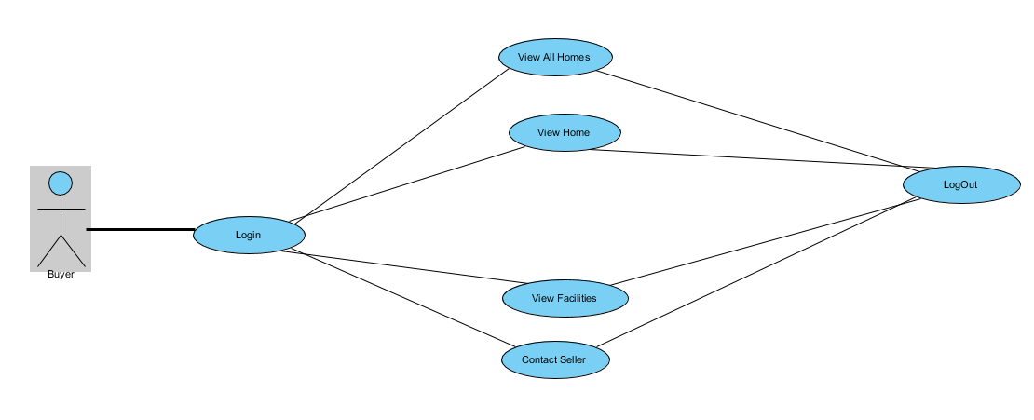

Figure 10: Buyer User Case Diagram

* **Seller:**

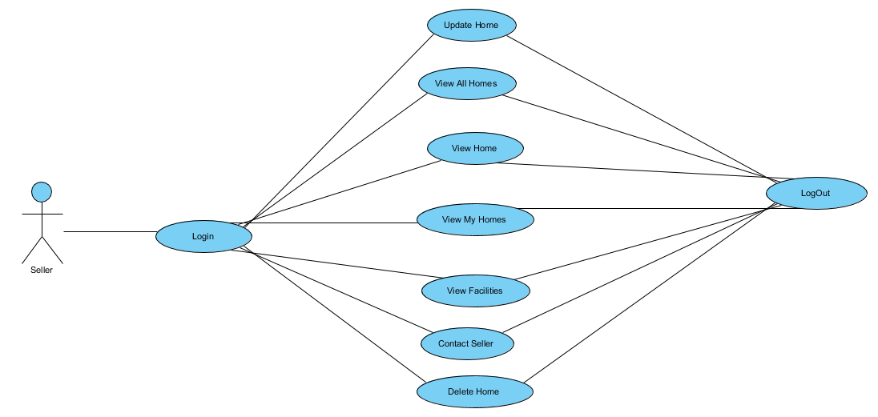

Figure 11: Seller User Case Diagram

* **Admin:**

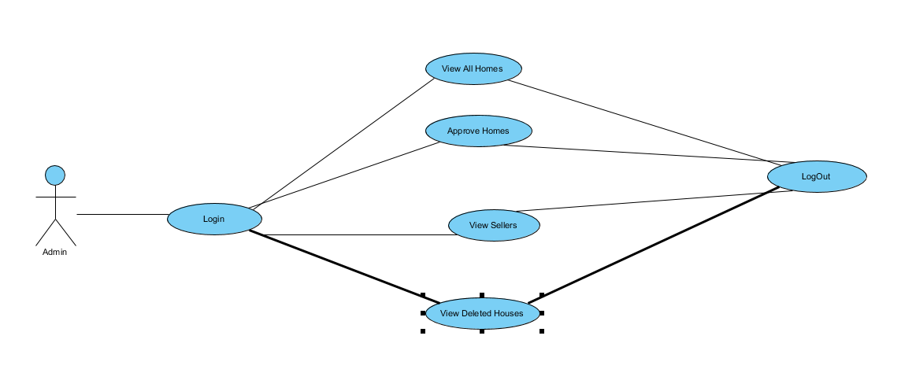

Figure 12: Admin User Case Diagram

**CHAPTER 4: PROJECT DEVELOPMENT**

**4.1 Database Implementation**

In this Angular Application ‘database first’ approach is used in backend and ‘HOMEDB’ database is created at initial stage.

* **Users**: This table consists of following attributes:
* **User Id -** This attribute is used for uniquely identifying each User. It is a primary key.
* **User Name -** This is a not null attribute. This field is used to get the username of the user.
* **E-Mail -** This is a not null and unique attribute. This field is used to get the email id of the user.
* **Phone Number -** This is a not null attribute. This field is used to get the phone number of the user.
* **Password -** This is a not null attribute. We have used encryption to store the password so that no can see the password except the user itself.
* **Role -** This attribute is a not null attribute will determine either user is Buyer or Seller or Admin.
* **Home Details:** This table consists of following attributes:
* **Home Id -** This attribute is used for uniquely identifying each Home. It is a primary key.
* **Home Name -** This is a not null attribute. This field is used to get the name of the home.
* **Home Type -** This is a not null and unique attribute. This field is used to get the type of house i.e Independent, Villa or Apartment.
* **Picture -** This is a not null attribute. This field is used to save the picture of the house.
* **City -** This is a not null attribute. This field is used to know the city in which the house is present.
* **Seller Id -** This is a not null attribute as well as foreign key and used to know the seller details that is present in the User table.
* **Address -** This is a not null attribute. This field is used to get the address where the house is present.
* **Area -** This is a not null attribute. This field is used to know the total area of the house.
* **BHK -** This is a not null attribute. This field is used to know the how many BHK house contains.
* **Pincode -** This is a not null attribute.This field is used to get the pincode of the city where the house is located.
* **Years -** This is a not null attribute. This field is used to get the details of the house that how many years before that house has been build.
* **Price -** This is a not null attribute. This field is used to get to know about the price of the house.
* **Status -** This is a not null attribute. This field is get to know the status of the house either it is available or it is sold to some buyer.
* **Facilties:** This table consists of following attributes:
* **Home Id -** This attribute is used for uniquely identifying each Home. It is a primary key.
* **Water -** This is a not null attribute. This field is used to get know whether water facility is present in the house or not.
* **Car Parking -** This is a not null attribute. This field is used to get know whether car parking facility is present in the house or not.
* **Gym -** This is a not null attribute. This field is used to get know whether gym is present in the house or not**.**
* **Play Area -** This is a not null attribute. This field is used to get know whether play area is present in the house or not.
* **Swimming Pool -** This is a not null attribute. This field is used to get know whether swimming pool is present in the house or not**.**
* **Gated Community -** This is a not null attribute. This field is used to get know whether gated community is present in the house or not**.**
* **Other Facilities-** This is a not null attribute. This field is used to know the other facilities of the house.

**4.2 TABLES**

1. **Users**

|  |  |  |  |  |
| --- | --- | --- | --- | --- |
| **No.** | **Field Name** | **Size** | **Type** | **Keys** |
| 1. | User Id | (100,1) | INT | Primary(IDENTITY) |
| 2. | User Name | 30 | VARCHAR | Not Null |
| 3. | Password | 20 | VARBINARY | Not Null |
| 4. | Role | 1 | INT | Not Null |
| 5. | Email ID | 50 | VARCHAR | Not Null (Unique) |
| 6. | Phone No | 10 | VARCHAR | Not Null (Unique) |

Table 1: Users Table

1. **Home Details**

|  |  |  |  |  |
| --- | --- | --- | --- | --- |
| **No.** | **Field Name** | **Size** | **Type** | **Keys** |
| 1. | Home Id | (0,1) | INT | Primary(IDENTITY) |
| 2. | Home Name | 30 | VARCHAR | Not Null |
| 3. | Home Type | 15 | VARCHAR | Not Null |
| 4. | Picture |  | Image | Not Null |
| 5. | City | 20 | VARCHAR | Not Null |
| 6. | Address | 200 | VARCHAR | Not Null |
| 7. | BHK | 1 | INT | Not Null |
| 8. | Area | 1 | INT | Not Null |
| 9. | Pincode | 6 | INT | Not Null |
| 10. | Years | 5 | INT | Not Null |
| 11. | Price | 6 | NUMERIC | Not Null |
| 12. | Seller Id | 1 | INT | Not Null(Foreign Key) |
| 13. | Status | 1 | INT | Not Null |

Table 2: Home Details Table

1. **Facilities**

|  |  |  |  |  |
| --- | --- | --- | --- | --- |
| **No.** | **Field Name** | **Size** | **Type** | **Keys** |
| 1. | Home Id |  | INT | Foreign Key |
| 2. | Water |  | BIT | Not Null |
| 3. | Car Parking |  | BIT | Not Null |
| 4. | Gym |  | BIT | Not Null |
| 5. | Play Area |  | BIT | Not Null |
| 6. | Swimming Pool |  | BIT | Not Null |
| 7. | Gated Community |  | BIT | Not Null |
| 8. | Other Facilities | 100 | VARCHAR |  |

Table 3: Facilities Table

On HOMEIN Data Access Layer is made by scaffolding in which LINQ Queries are written and with the help of this basic structure is formed. CRUD Operations are performed on database in order to proceed further in this project. CRUD stands for CREATE, READ, UPDATE, DELETE.

The main functions used in Data Access Layer are:

1. **GetNextHomeId:**

This function allows to retrieve the home Id from HomeDetails Table.

1. **ValidateCredentials:**

This function allows to validate credentials by checking whether the entered user Id and password is correct or not.

1. **GetAllHomeDetails :**

This function allows to retrieve all the houses that are present from the HomeDetails table.

1. **GetHomesBySellerId :**

This function allows to retrieve all the houses from the HomeDetails table of the particular seller.

1. **GetHomeFacilities:**

This function allows to retrieve all the facilities that are present from the Facilities table of the particular house.

1. **GetContactDetails:**

This function allows to retrieve the contact details of the seller whose house buyer is in need of buying.

1. **GetHomesByTypeCityPrice:**

This function allows to retrieve all the houses according to the filters that are applied i.e By Type(Apartment/Villa/Independent) or Price or City.

1. **AddNewHome :**

This function is used to add the new house in the HomeDetails Table.

1. **UpdateHomeDetails:**

This function is used to update the details of the houses in the HomeDetails table.

1. **UpdateFacilities:**

This function is used to update the facilities of the particular house in the Facilities table.

1. **DeleteHome :**

This function is used to delete the details of the house from the HomeDetails table.

1. **GetAllPendingApprovalHomes:**

This function is used to add the homes to the homedetails table which can be only done by the admin.

1. **AddUser:**

This function is used to add the buyers and sellers in the users table.

**3.2. COMPONENTS**

Significant piece of the improvement with Angular 4 is done in the components. Components are fundamentally classes that collaborate with the .html record of the part, which gets showed on the program. We have seen the record structure in one of our past sections. The file structure has the application component and it comprises of the following files –

* app.component.css
* app.component.html
* app.component.spec.ts
* app.component.ts
* app.module.ts

Components that are present in my project are described as follows:

* **Add New Home –** This component allows us to add the details of the house in the database..
* **Add New User –** This component allows us to add the details of the user in the database.
* **Delete Home –** This component allows us to delete the details of the house from the database.
* **Login –** This component allows us to validate the credentials of the user to enter in the portal to see the houses.
* **Starting Page –** This is the homepage of the app.
* **Update Home –** This component allows us to update the details of the home in the database.
* **Update User –** This component allows us to update the details of the buyer or seller.
* **View Facilities –** This component allow us to view the facilities of the particular house that are present in the database.
* **View Home –** This component allow us to view the particular house that are present in the database.
* **View Homes –** This component allow us to view all the homes the homes that are present in the database.
* **View Homes By Seller Id –** This component allow us to view all the homes of the particular seller that are present in the database.
* **View Seller –** This component allow us to view all the details of the seller are present in the database.
* **Admin Approval –** This component allow us to approve all the homes for the seller that are not approve or pending for the approval by the admin.
* **AdminView Houses-** This component allow us to view all the homes that are present in the database.

**CHAPTER 5: RESULTS AND SCREENSHOTS**

**SCREENSHOTS :**

* **HomePage**

*(i)*

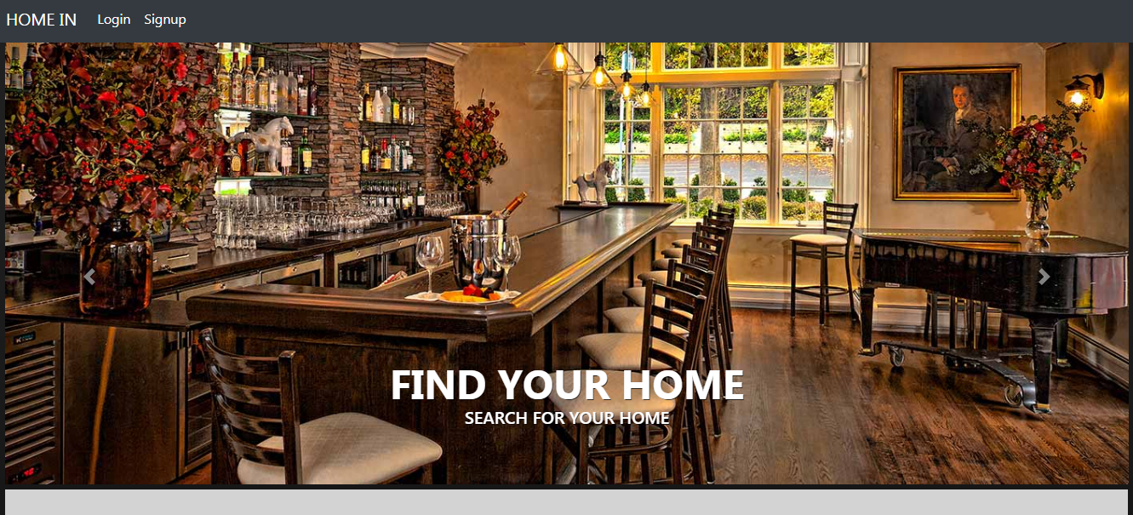

Figure 13: Home Page Layout 1

*(ii)*

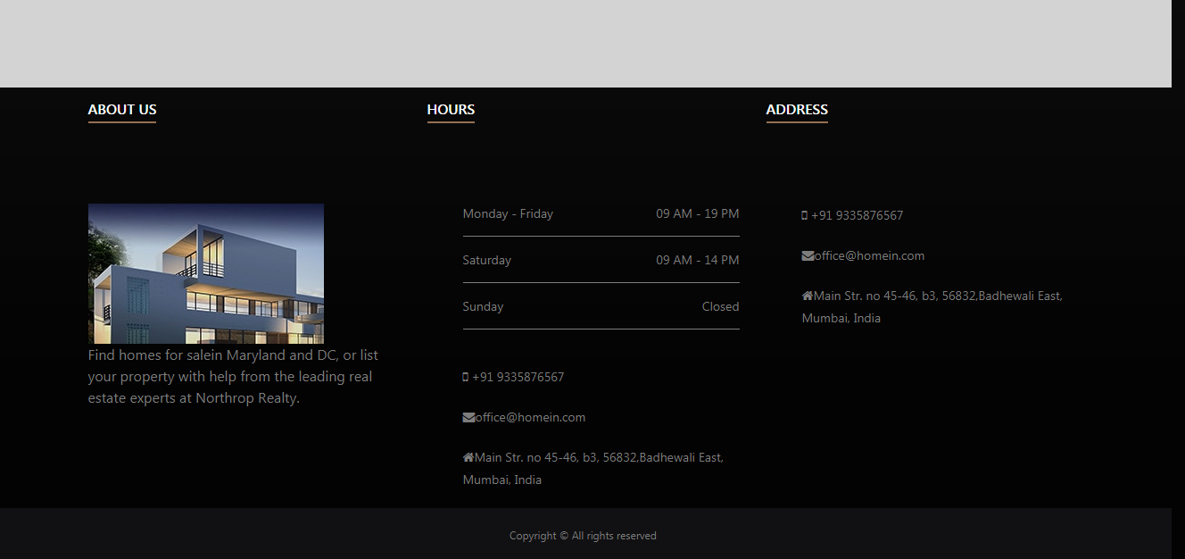

Figure 14: Home Page Layout 2

* **Login**

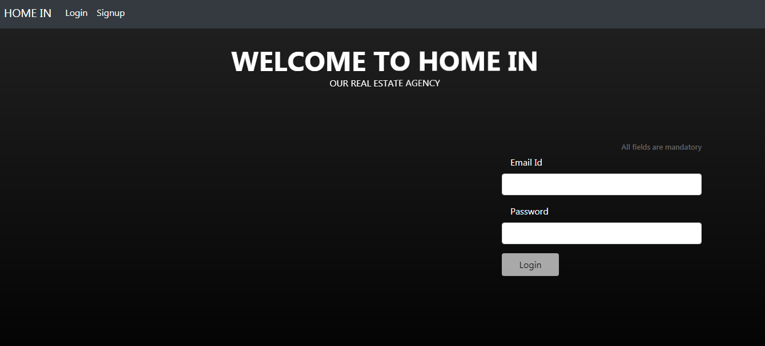

Figure 15: Login Page Layout

* **Register**

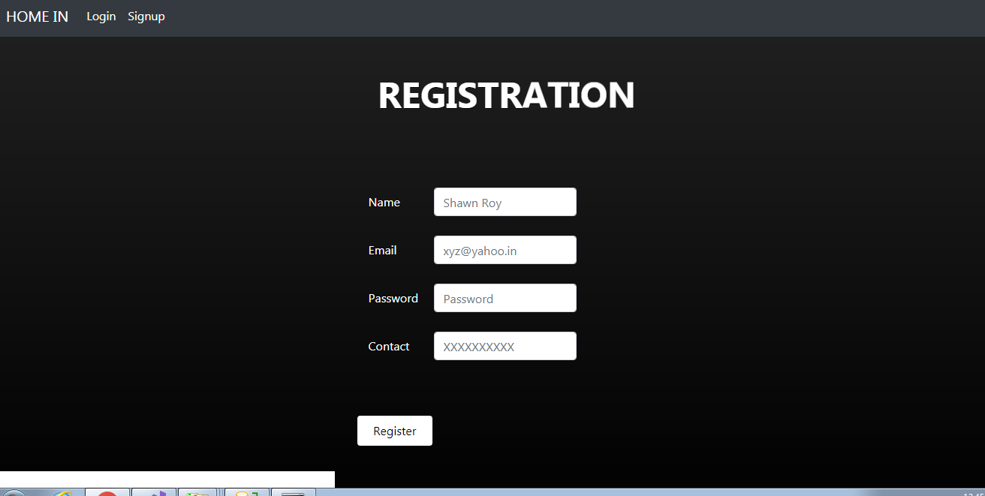

Figure 16: Register Page Layout

* **View All Homes**

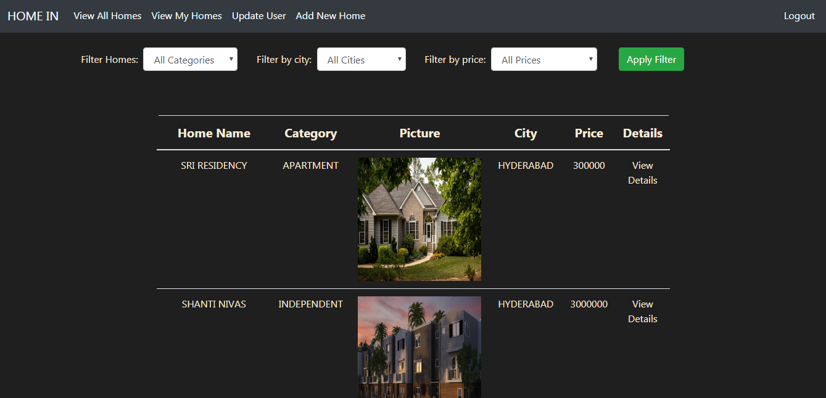

Figure 17: View All Homes Page Layout

* **View Particular Home**

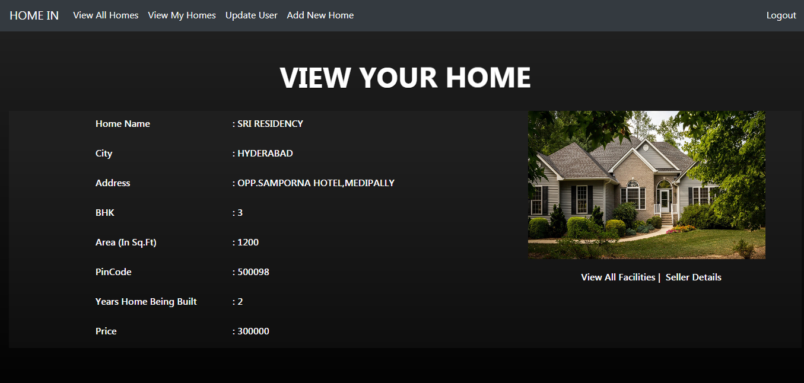

Figure 18: HomeDetails Page Layout

* **View Facilities**

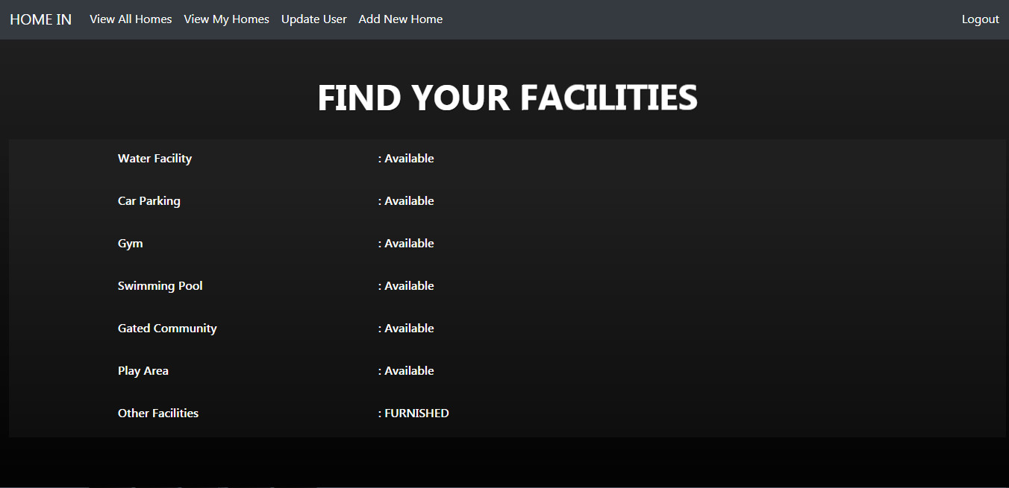

Figure 19: View Facilities Page Layout

* **Contact Seller**

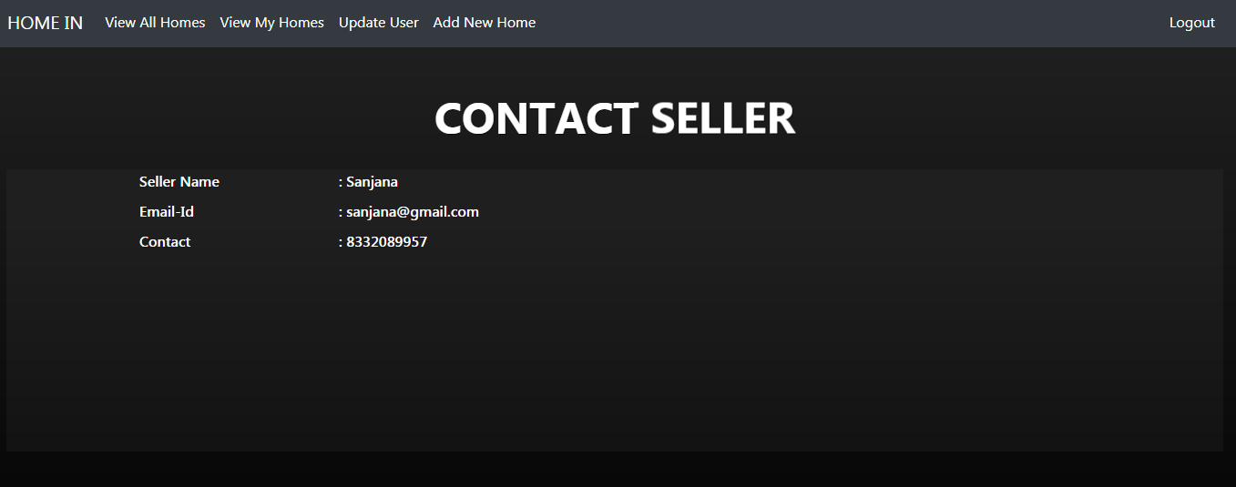

Figure 20: Contact Seller Page Layout

* **View Seller Homes(By seller itself)**

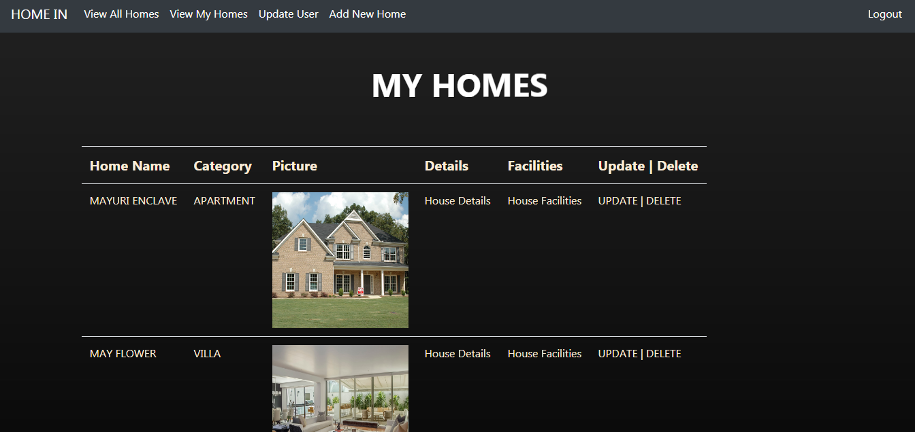

Figure 21: ViewMyHomes Page Layout

* **Add Home**

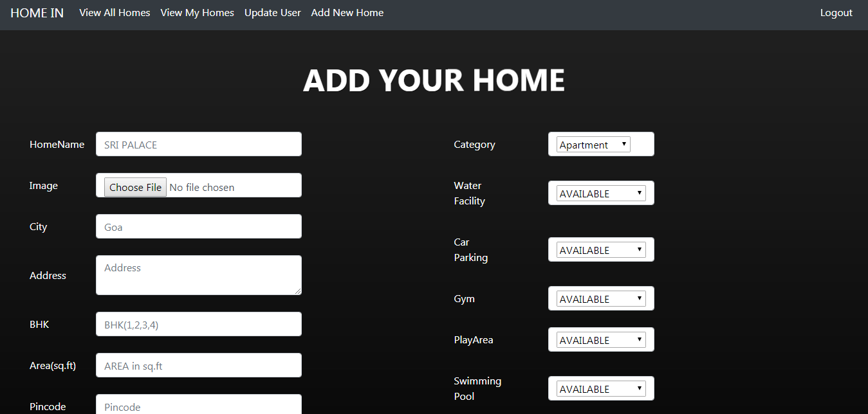

Figure 22: Add New Home Page Layout

* **Update Home**

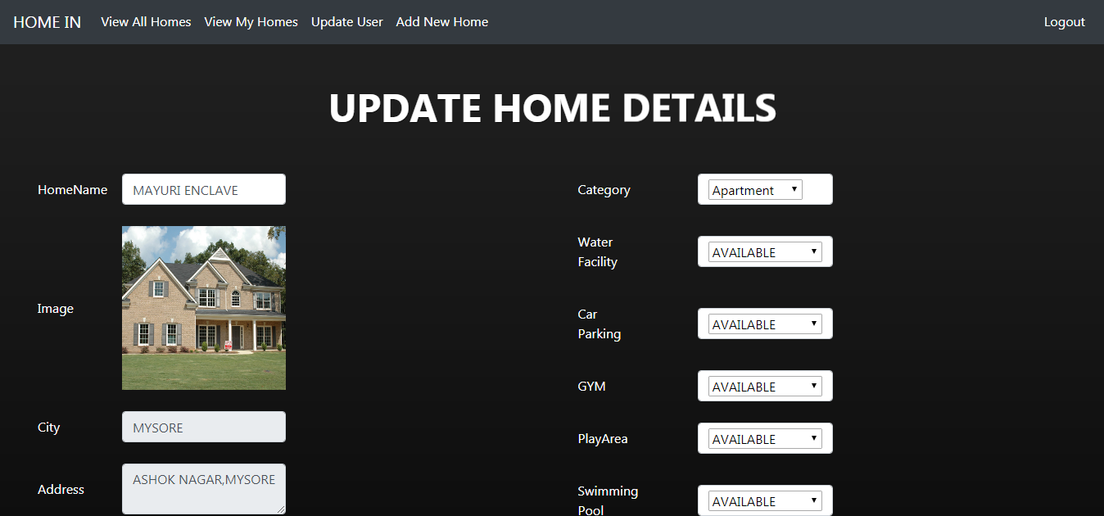

Figure 23: Update Home Page Layout

* **Update User**

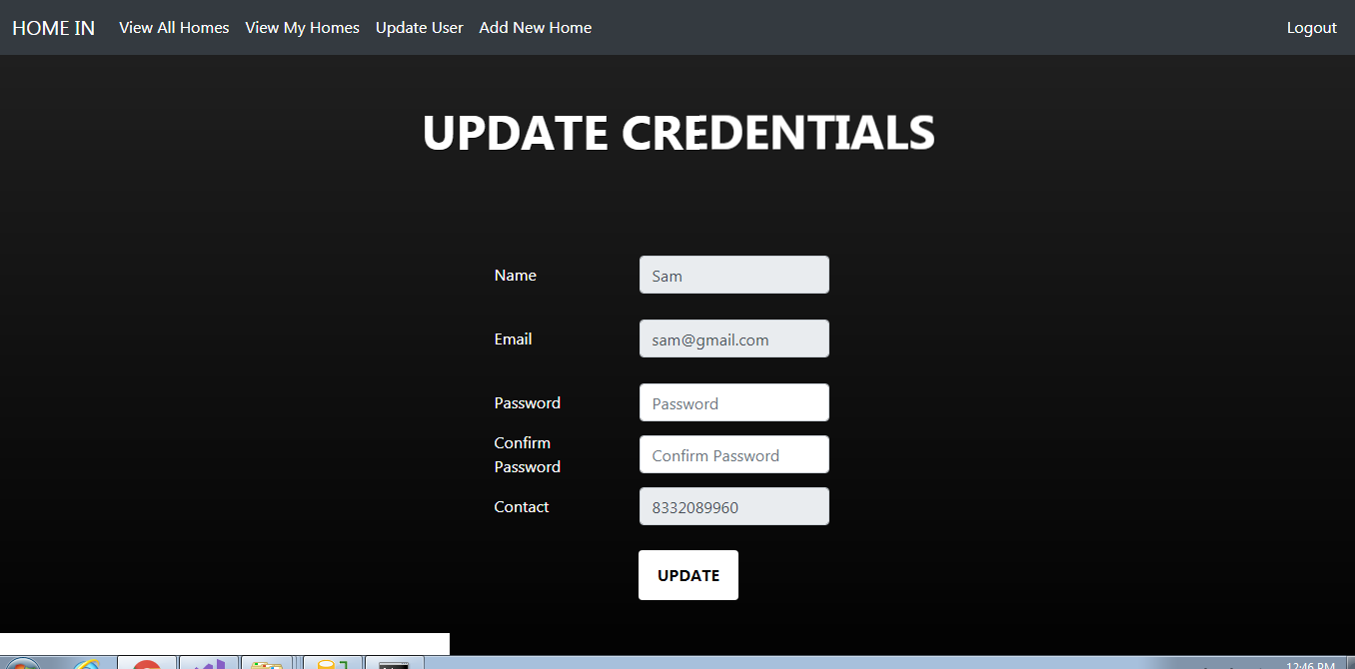

Figure 24: Update User Page Layout

* **Delete Home**

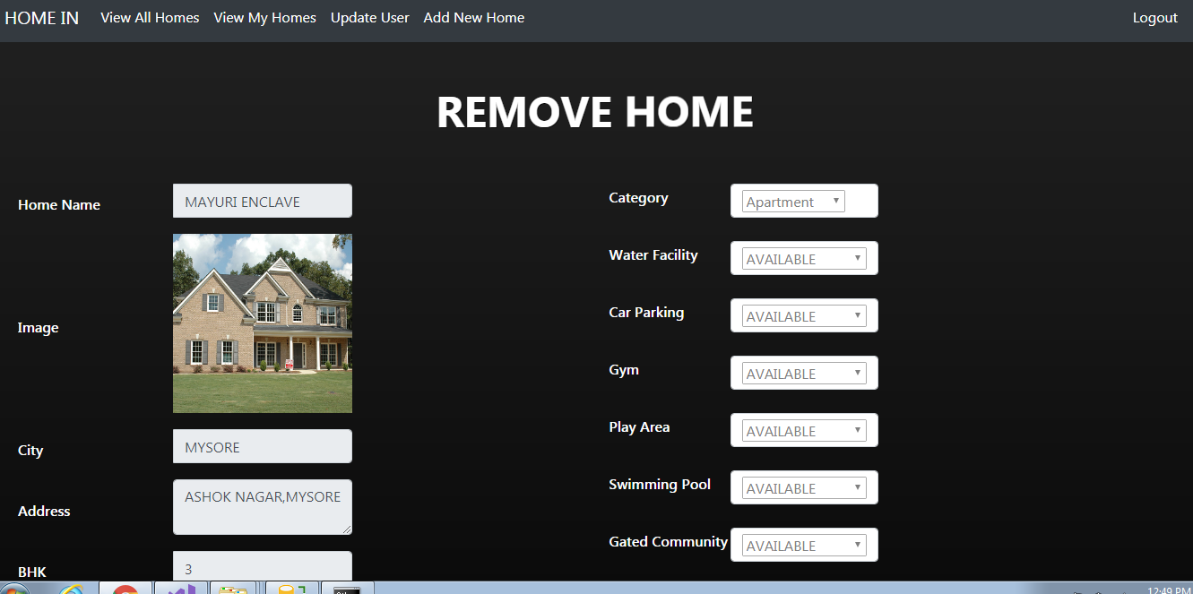

Figure 25: Delete Home Page Layout

# CHAPTER 6: CONCLUSION AND FUTURE SCOPE

## 6.1 Conclusion

The essential purpose of the proposed task is to develop a web application which can be profitable for houses buying and selling. We have gotten another framework arranged in the wake of perceiving issues in existing manual system. In this, an easy to use GUI is proposed which can be utilized by a wide range of customers. In the task, we made an undertaking to effectively show the possibility of land the executives framework formally existing in the overall population. We depict the proposed system and clear up the highlights executed by our proposed structure. We in like manner give a compact audit of the advancements used in the midst of the improvement of our proposed structure. This endeavor can be furthermore refined and connected by exhibiting new and progressively inventive highlights.

The task will help the specific houses to be overseen and robotized. It will lessen the human effort and make the assignment of buyer, seller and executive easier. It is profitable to use and easy to chip away at. Therefore recollecting the central focuses and applications; we are developing a Real Estate the board website which has supreme administration control of customer and specific organization of different events.

The venture was effectively actualized and tried for quality, accuracy and execution. Every one of the destinations and necessities were practiced and every one of the requirements are met.

**6.2**  **Goals Achieved**

We have gone through literature and information from research papers. We have reviewed most popular algorithms which could have assisted us in this project and selected only one of them based on the flexibility or resources available. We have used Angular for basic implementation of this project and using built in libraries we have come up with some useful results. User Interface is user friendly and easy as well. This project is flexible for future enhancement. We have taken all the buyers and sellers have come under one roof. We have reduced the manual work and working towards for making this easy and convenient for the other users.

**6.3 Future Scope**

* It can be extended to reach to a lot of the people on their mobile handsets, by using android application and enhanced features.
* It can have an additional functionality where buyers and sellers can register themselves and add or, update or delete their houses according to the availability.
* Its performance can be increased by making it perform even during the peak loads.
* Logs can be maintained for the changes being done by the buyer or seller. The timestamp and person responsible should be saved for both of them.
* More offers and deals can be presented on the website to attract more customers and increase its scalability.
* The site can be inculcated with a lot of payment options instead of just one.